Shabbos Stories For
chanukah 5786
Volume 17, Issue 14 25 Kislev-2 Tevet /December 14-22, 2025
Printed L’illuy nishmas Nechama bas R’ Noach, a”h
For a free subscription, please forward your request to keren18@juno.com
Past emails can be found on the website – ShabbosStories.com

The Missing Shamash Lighter

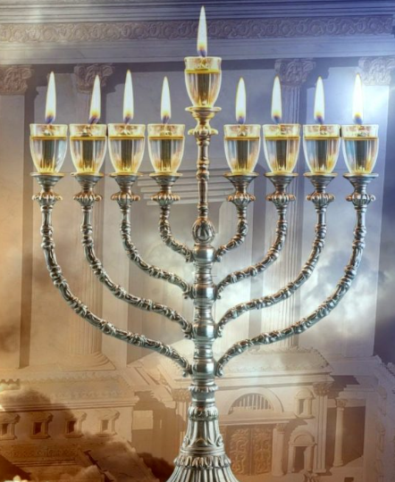

The followers of Rabbi Dov Ber, the Maggid of Mezritch, awaited him to come into the Shul for the lighting of the menorah on the first night of Chanuka. The past few years, Rabbi Meshulam Zusha of Anapoli, one of the Maggid's greatest disciples, had been honored with lighting the shamash candle. Reb Zusha would then hand it to the Maggid who lit his menorah from it. But tonight, Reb Zusha was nowhere to be seen.
The Chassidim wondered if his absence was the reason why the Maggid had not yet lit the menorah. Minutes, then hours ticked by, as the Chassidim waited for their Rebbe to emerge. Finally, close to midnight, the Maggid emerged from his room and walked towards the menorah. The Maggid started mumbling to himself and said quietly, "Zusha will not be with us tonight. We will light the menorah now."
The Maggid honored another of his Chassidim with the privilege of kindling the shamash, the Rebbe then said the Berochos and the single wick was lit. Then all of the Chassidim joined together in singing the traditional Chanuka songs. The next morning, just as the Maggid and his Chassidim were finishing davening, Reb Zusha walked in. Weary from traveling, Reb Zusha shuffled over to his customary place and dropped down on the bench.
His friends came over and gave him a hearty welcome. One of them reported, "The Rebbe waited a long time for you last night. What happened?"
"After we light the Chanuka menorah tonight," promised Reb Zusha, "and with the Rebbe's permission, I will tell you what happened."
All of the Chassidim gathered around the Maggid's menorah on the second night of Chanuka. After the Maggid lit the menorah everyone eagerly listened to Reb Zusha's story.
"As you all know, immediately after Chodesh Tishrei, it is my custom to travel throughout the small villages and hamlets near Mezritch. I go from town to town, speaking with the adults and teaching the children Torah telling them about the wonders of our heritage. I also speak to them about how Hashem loves each and every single Jew and that they are all important to Him. I tell them about our Rebbe and explain some of the Rebbe's teachings.
"Each year, I plan my schedule so that I can return Mezritch in time for Chanuka. Yesterday, I was on my way back to Mezritch when a terrible snowstorm started. I pushed on through the storm, though many times I felt I could not continue. Knowing that I would soon be back in Mezritch near the Rebbe was what kept me going.
"The storm worsened and I soon realized that I would have to stop and rest a bit before continuing, if I wanted to make it to Mezritch at all. So, I stopped at the home of Yankel in a village not too far from Mezritch. By this time, it was already quite late in the afternoon. I pounded and pounded on the door until finally, someone called out, 'Who is it?' 'It is I, Zusha,' I said loudly.
“Yankel's wife opened the door. She looked absolutely terrified as she bid me inside. I noticed that the children, too, looked frightened. The poor woman burst out, 'Yankel left the house early this morning to gather firewood. He promised he would come back early, for even then he saw we were in for a terrible storm. It is late already and still he has not returned,' she wailed.
“For a split second I hesitated. If I went into the forest now, who knew if I would come out alive? But I knew I had no choice. I put on my coat and scarf once again and set out toward the forest. I passed a few rows of trees when I saw the upright form of a man covered with snow. Only his face was visible in that white blur. I saw right away that it was Yankel, and I thought for sure that he had frozen to death. But when I came very close, I noticed to my surprise, that he was still breathing.
“I brushed Yankel off and tried to warm him up. Somehow I managed to drag and carry Yankel back to his house where his wife and children greeted us with cries of joy. With my last ounce of strength, I deposited Yankel on the bench near the stove and fell to the floor myself. Miraculously, Yankel's wife was able to thaw him out. She brought us a bottle of strong hard liquor which we drank eagerly to warm our insides. At about midnight we felt sufficiently strong enough to stand up and light the Chanuka menorah. As we said the prayer, who made miracles for our ancestors, in those days at this time, we knew without a doubt that Hashem had made a miracle for us now, too. As soon as the sun rose in the morning I set out for Mezritch and arrived when you saw me this morning."
Reb Zusha finished his story. The Maggid looked deeply into Reb Zusha's face. "Know, Zusha, that in Heaven they waited, as it were, to light the Divine Chanuka menorah until you lit the menorah together with Yankel. In the merit of your saving a Jewish soul from death, the Heavens awaited you."

Reprinted from the Parshas Vayishlach 5786 email of Rabbi Dovid Caro’s Inspired by a Story.

Sour Pickles and Sour Milk: A Story for Chanukah
By Rabbi Lazer Brody

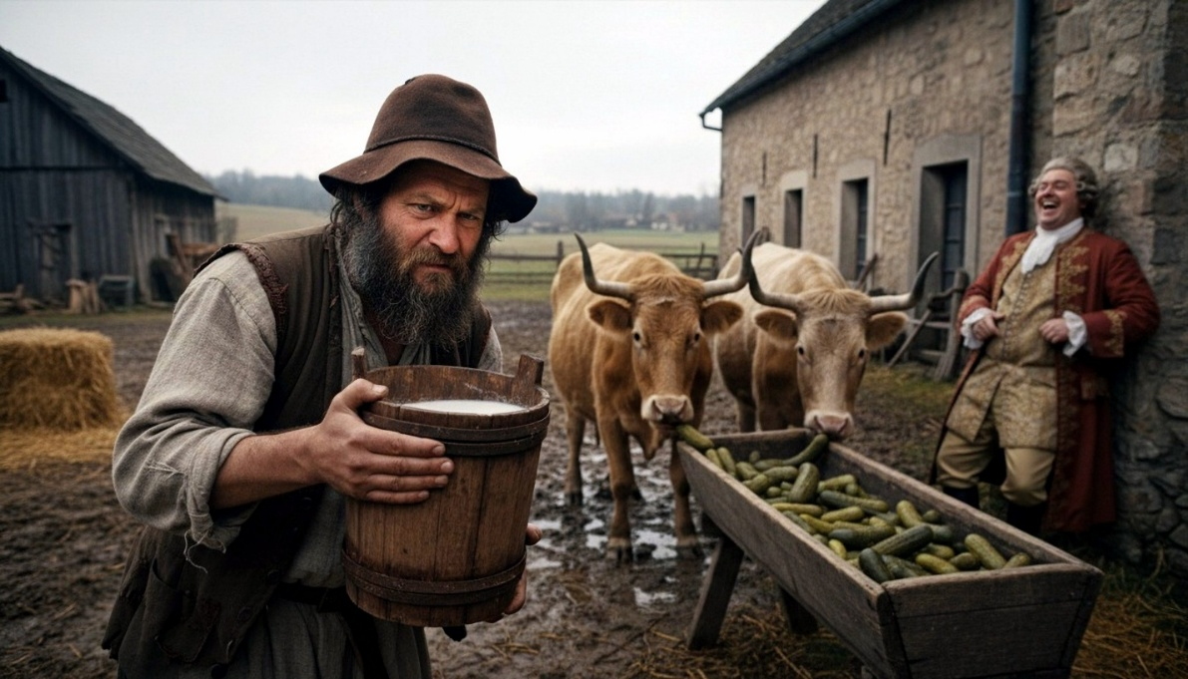
This year, the first night of Chanukah is Sunday night, Dec. 14, 2025. Chanukah is not simply a child’s celebration that the good army of the few righteous defeated the evil army of the masses some 2,200 years ago. The struggle of Chanukah continues to this very day.
The Hellenists
The Seleucid Greeks who conquered ancient Israel under Antiochus IV were “benevolent” in that they didn’t kill Jews unconditionally. The “Hellenist Jews” were the ones who were willing to sacrifice their Judaism and bend to the winds of heresy and political correctness. They discarded their faith and their ancient Hebrew language and spoke Greek. They looked like Greeks, dressed like them and acted like them. The Greeks would gladly accept them into their schools, their social circles, and their homes. Such assimilation was worse than a physical death, for the body is sorely limited. Yet, assimilation and capitulation to the Greeks meant death to the soul. Since the soul transcends time and space, its death is a much greater tragedy than death of the body that disintegrates anyway within ninety years or so.

The Few Against the Many
In the Al HaNissim prayer for that we say several times daily during Chanukah, we thank Hashem for delivering “the mighty into the hands of the weak, the masses into the hands of the few.” A tiny-faction of emuna-steadfast ancient Israelites fought not only the Greeks, but the huge majority of their fellow Jews who were Hellenist assimilationists.
The battle of the righteous few against the ignorant masses still rages. Rebbe Nachman of Breslov forewarned us of the dangers we’d be exposed to in the generation before Moshiach (Likutei Moharan, 220). This is the war of emuna, the struggle between lightness and darkness, between emuna and heretical modern society and media. This battle is as difficult today as it ever was. Rebbe Nachman warned us:
“A tremendous spirit of agnosticism is coming to the world. Agnosticism will come to the world as a test from on high. I know that my followers will be strong and remain firm in their faith without this warning, but I am revealing this to further encourage them. Let them know that this has already been predicted… ”
With a deep and painful sigh Rebbe Nachman would say, “Woe! How can a few men stand up against the whole world?!”

Out Tool of Triumph
This very day, we see just how true Rebbe Nachman’s prediction is. Hashem’s faithful are few, and the non-believers appear to have the upper hand, even here in Israel, “the King’s palace.” Every day, we hear about new evil decrees against the Torah and those who cling to it. What can we possibly do to avoid being washed away by the flood of agnosticism? How does one combat the Hellenistic assimilationist spirit of the 21st Century?
Don’t despair! Just as Rebbe Nachman predicted the struggle with his holy inspiration, he also gave us the secret to winning the battle. He said that the faithful few that rise to strengthen their emuna – their pure and steadfast faith in Hashem – will not only survive, but ultimately, they will flourish. The Rebbe warned that the agnostic masses of our generation will rise up against the faithful few. With emuna, Hashem’s faithful few are able to restore their souls, strengthen their hearts, and weather the torrents of agnosticism. Without it, they are spiritually weak and ruined, as we’ll see in the following parable, with Hashem’s loving grace:

Sour Pickles, Sour Milk
Shmelke wasn’t exactly the brightest person in the shtetl, to say the least. Yet, thanks to Hashem’s unlimited compassion, even simple Shmelke managed to make a living from the milk of his three cows, which he’d deliver fresh every day – except Shabbat, of course – to his neighbors.
Yosef Grednik, in contrast to Shmelke, was the wealthiest person in the area. He owned the mill, the distillery, and the pickle factory. There wasn’t a person within a hundred-mile radius that didn’t bake with Grednik’s flour, drink Grednik’s vodka, or eat Grednik’s pickles. Yet, with all his money, Yosef Grednik was resentful about parting with a single kopeck, much less a ruble.
One day, the workers in Yosef’s pickle factory made a mistake, and added too much vinegar to a twenty-barrel batch of pickles. The pickles became so sour that the fumes from the brine could kill any fly that came too close to the barrel. Yosef knew that the pickles were inedible and unmarketable. He fumed. Then suddenly, an idea illuminated his conniving brain. He ordered his workers to dispose of the sour brine, wash off the pickles, and then put them in baskets. He then sold them as low-cost fodder for gullible Shmelke’s three cows. The miser was delighted to salvage a few coins from what he would have otherwise thrown in the garbage dump.

A Bargain, or Not?
Shmelke was happy to buy such “high-grade” fodder for his cows at such a cheap price. The cows welcomed the sour pickles as a palatable break from their normal repast of straw and hay. They ate the pickles with the same enthusiasm that they would eat fresh corn.
Within a day or two, people began to complain. “Shmelke, your milk is sour!” Shmelke couldn’t understand; every day, he’d distribute the milk within hours of milking. There was nothing fresher in all of Transylvania. The customers wanted their money back. Shmelke refused. Finally, the plaintiffs demanded a hearing in the Rabbi’s study.
The wise elderly sage heard both sides. He directed his first question at Shmelke: “Have you fed the cows anything different lately?” he asked. Shmelke nodded in the affirmative, and told the Rabbi about the “cucumbers” he bought from Yosef Grednik. The Rabbi didn’t need to hear any more. He knew that Shmelke was the innocent victim of Grednik’s greed and treachery. He explained to the simple milkman how sour fodder leads to sour milk. Then, he summoned Yosef Grednik and demanded that the latter reimburse poor Shmelke and his customers. Yet, nobody reimbursed the poor cows for their stomach ache, which lasted for another week!

The Moral of the Story
Unsuspecting Shmelke is symbolic of the Jew; Shmelke’s three cows represent nefesh, ruach, and neshoma, the three parts of the soul. Sour pickles are the agnostic media and the foreign ideologies that ruin the “produce” of a person, his emuna, Torah, and mitzvoth, which the milk symbolizes. Grednik is the Evil Inclination that tries to “sour” one’s emuna, and bring him or her down from the lofty levels of pure and simple faith – spiritually above the stars – to the depths of agnosticism.
Since the beginning of man, the Greeks, Hellenists, and other enemies of emuna have been the overwhelming majority. Chanukah is the celebration that the pure oil with the seal of the High Priest – a national symbol of pure Torah ideology – is never fully contaminated by our enemies. Even though the faithful to Torah are the few, they nonetheless weather the trials of the generations and the persecutions of the masses. Rebbe Nachman promises that they will be the privileged few that will merit greeting Moshiach in a rebuilt Jerusalem, speedily and in our time, amen.

Reprinted from the current website of Lazerbeams.com

Flames of Peace
By Rabbi Paysach J. Krohn
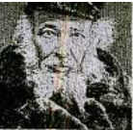
R’ Nachum’ke of Horodna

The time for lighting the Chanukah menorah had long passed, and the young Chofetz Chaim, spending Chanukah in the home of his revered Rebbi, R’ Nachum’ke of Horodna, could not understand why the tzaddik still hadn’t lit. Hours went by until, very late at night, R’ Nachum’ke’s wife finally came home — only then did he light the menorah.

When the Chofetz Chaim respectfully asked why he had waited so long, R’ Nachum’ke explained: “The Gemara says that if someone has money for only one candle on the Friday night of Chanukah, he must buy a Shabbos candle, because Shalom Bayis takes precedence over the Chanukah light. My wife would have been distressed had I not shown her the courtesy of waiting for her.
“If the Gemara uses Chanukah candles to teach the importance of Shalom Bayis, how could I damage Shalom Bayis through the Chanukah candles? I lit when she returned, at a time still acceptable according to halacha.”

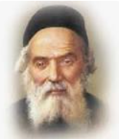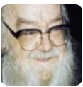
The Chofetz Chaim R’ Sholom Schwadron

When R’ Sholom Schwadron repeated the story, he added a striking insight: Shalom Bayis also meant that when R’ Nachum’ke’s wife arrived, he did not complain that her lateness caused him to wait to perform a mitzvah — he knew even that would diminish peace in the home. (Excerpted from the ArtScroll book – “Around the Maggid’s Table”)

Reprinted from the Parshas Vayeishev 5786 email of The Weekly Vort.

